1. Verify that your java bin folder in the system PATH

f.e C:\Program Files\Java\jdk-21\bin\

to check enter in cmd : jar –version

if you get the answer like “jar 21.0.8”, everything is OK

if not open “Edit the system Environment Variables

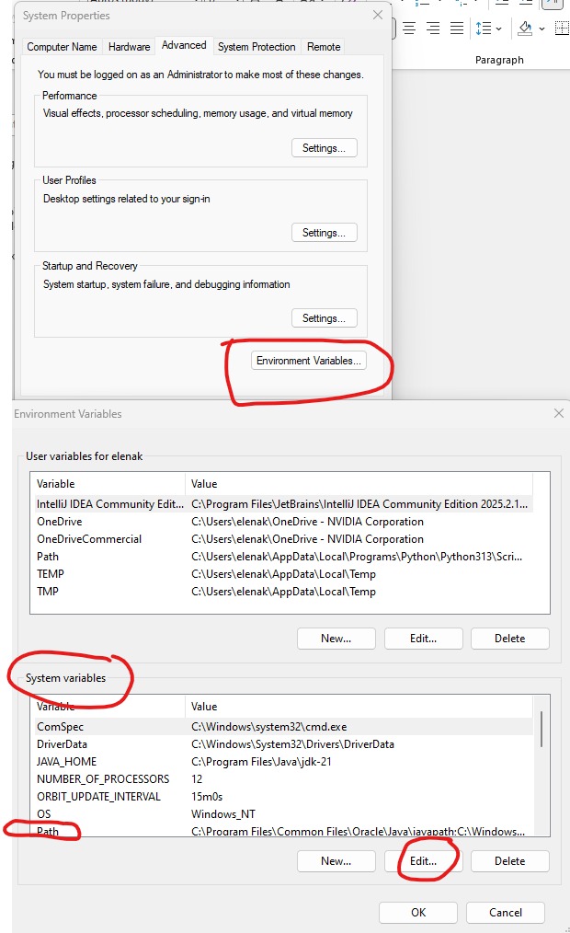

OK->OK->OK

Open the new cmd and check jar –version

1. Got ot the S-Emulator folder and run build_all.bat
2. It will create folder dist includes server.jar and client.jar
3. Copy the following files/folders to the some folder , it will be shared :

├─ dist/

│ ├─ server.jar

│ └─ client.jar

├─ lib/

├─ run_server.bat

└─ run_client.bat